GIT AND GITHUB ASSIGNMENT

1. Create a directory ‘project_dir’ & cd to project_dir

kanduri yashwanth@yashwanth MINGW64 ~

$ mkdir project_dir

kanduri yashwanth@yashwanth MINGW64 ~

$ cd project_dir

1. Intitialize git version database

$ git init

Initialized empty Git repository in C:/Users/kanduri yashwanth/project_dir/.git/

3.create a new file index.html

kanduri yashwanth@yashwanth MINGW64 ~/project_dir (master)

$ touch index.html

4.get git status. You would find index.html file as untraced

$ git status

On branch master

No commits yet

Untracked files:

(use "git add <file>..." to include in what will be committed)

index.html

nothing added to commit but untracked files present (use "git add" to track)

5.stage the index.html file

kanduri yashwanth@yashwanth MINGW64 ~/project_dir (master)

$ git add index.html

6. commit index.html

$ git commit -m "first commit of index.html"

[master (root-commit) 46a61b0] first commit of index.html

1 file changed, 0 insertions(+), 0 deletions(-)

create mode 100644 index.html

7.make few changes in index.html & create a new filr info.txt file

kanduri yashwanth@yashwanth MINGW64 ~/project_dir (master)

$ touch info.txt

8. check git status.you should find index.html&info.txt as untracked

$ git status

On branch master

Changes not staged for commit:

(use "git add <file>..." to update what will be committed)

(use "git restore <file>..." to discard changes in working directory)

modified: index.html

Untracked files:

(use "git add <file>..." to include in what will be committed)

9. configure git to ignore all text file.

$ git status

On branch master

Changes not staged for commit:

(use "git add <file>..." to update what will be committed)

(use "git restore <file>..." to discard changes in working directory)

modified: index.html

Untracked files:

(use "git add <file>..." to include in what will be committed)

.gitignore

no changes added to commit (use "git add" and/or "git commit -a")

-a")

10. again check the git status . you should find only index.html as untracked

Untracked files:

(use "git add <file>..." to include in what will be committed)

index.html

11. state and commit index.html

$ git commit -m "commiting htm"

[master (root-commit) 46a61b0] first commit of index.html

1 file changed, 0 insertions(+), 0 deletions(-)

create mode 100644 index.html

12.log all your comments for far

$ ls

index.html info.txt

13. make some changes in index.html

<html>

<head>

<title>assignment</title>

</head>

<body>

complete the assignment!!

</body>

</html>

14. revert the changes made in the previous step using git command

$ git rm --cached index.html

rm 'index.html'

15. Again change html file

<html>

<head>

<title>assignment</title>

</head>

<body>

complete the assignment!!@

</body>

</html>

16. stage index.html file

$ git add index.html

17. revert back the last stage

$ git rm --cached index.html

rm 'index.html'

18. rename add command to my-add

kanduri yashwanth@yashwanth MINGW64 ~/project_dir (master)

$ alias a="add"

19. using my-add command stage and commit index.html

$ git config --global alias.a add

kanduri yashwanth@yashwanth MINGW64 ~/project_dir (master)

$ git a index.html

kanduri yashwanth@yashwanth MINGW64 ~/project_dir (master)

$ git commit -m "last commit in sec0"

[master adc9a0d] last commit in sec0

1 file changed, 1 insertion(+)

20.revert the last commit

#git branching

22. create an empty directory assignments and cd to assignments

kanduri yashwanth@yashwanth MINGW64 ~

$ mkdir assignments

kanduri yashwanth@yashwanth MINGW64 ~

$ cd assignments

23. create a README.txt file in assignments and write information about the assignments folder

kanduri yashwanth@yashwanth MINGW64 ~/assignments

$ touch README.txt

24. commit README.txt file

$ git commit -m "first commit "

[master (root-commit) 46a61b0] first commit of index.html

1 file changed, 0 insertions(+), 0 deletions(-)

create mode 100644 README.txt

25.now create a new branch html assignment folder

kanduri yashwanth@yashwanth MINGW64 ~/Assignment (master)

$ git branch html_assignment

26. switch to html branch

kanduri yashwanth@yashwanth MINGW64 ~/Assignment (master)

$ git checkout html_assignment

Switched to branch 'html_assignment'

27. copy all HTML assignments inside ‘ASSignemnt “folder

kanduri yashwanth@yashwanth MINGW64 ~/Assignment (html_assignment)

$ touch ht.html

28.commit html assignemnts into html assignments branch

kanduri yashwanth@yashwanth MINGW64 ~/Assignment (html_assignment)

$ git commit -m "commit ht"

[html_assignment defd040] commit ht

1 file changed, 1 insertion(+)

create mode 100644 ht.html

29.make minor changes into few files belonging to html-assignemnts branch

#changed the content

30.commit those changed files

kanduri yashwanth@yashwanth MINGW64 ~/Assignment (html_assignment)

$ git commit -m "com"

[html_assignment 9cb8d13] com

1 file changed, 1 insertion(+), 1 deletion(-)

31.switch to master branch

kanduri yashwanth@yashwanth MINGW64 ~/Assignment (html_assignment)

$ git checkout master

Switched to branch 'master'

32.make minor changes into README.txt file $ commit those changes into master

kanduri yashwanth@yashwanth MINGW64 ~/Assignment (master)

$ git commit -m "co"

[master e43de74] co

1 file changed, 1 insertion(+), 1 deletion(-

33.Again switch to html_assignemnt branch

$ git checkout html_assignment

Switched to branch 'html_assignment'

34.make minor changes into few files belonging to html-asignemnts branch

#content changed

35.commit those changes

$ git commit -m "c"

[html_assignment e772080] c

1 file changed, 1 insertion(+), 1 deletion(-)

36.switch to master

$ git checkout master

Switched to branch 'master'

37.Merge html_assignemnts branch into master .Comfirm all html assignemnts are

shown in master

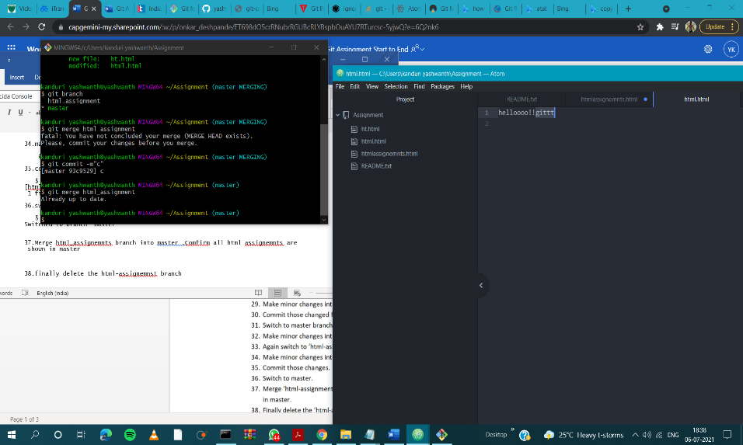

38.finally delete the html-assignemnst branch

kanduri yashwanth@yashwanth MINGW64 ~/Assignment (master)

$ git branch -d html_assignment

Deleted branch html_assignment (was e772080).

Section 2 css assignment

1. Create a new branch css-assignments

kanduri yashwanth@yashwanth MINGW64 ~/Assignment (master)

$ git branch css-assignment

1. Switch to css-assignemnts branch

$ git checkout css-assignment

Switched to branch 'css-assignment'

1. Copy all css assignemnts inside the Assignments folder

kanduri yashwanth@yashwanth MINGW64 ~/Assignment (css-assignment)

$ touch 1.css

kanduri yashwanth@yashwanth MINGW64 ~/Assignment (css-assignment)

$ touch 2.css

1. Commit CSS assignemnts into css-assignments branch

kanduri yashwanth@yashwanth MINGW64 ~/Assignment (css-assignment)

$ git add 1.css

kanduri yashwanth@yashwanth MINGW64 ~/Assignment (css-assignment)

$ git commit -m "1"

[css-assignment 1fa1ee8] 1

1 file changed, 0 insertions(+), 0 deletions(-)

create mode 100644 1.css

1. Make minor changes into README.txt file on line 1 belonging to css-assgnments branch

#content changed

1. Commit those changes files

$ git commit -m "1"

[css-assignment 1fa1ee8] 1

1 file changed, 0 insertions(+), 0 deletions(-)

create mode 100644 README.txt

1. Switch to master branch

kanduri yashwanth@yashwanth MINGW64 ~/Assignment (css-assignment)

$ git checkout master

Switched to branch 'master'

1. Make minor changes into README.txt file on line 3 & commit those chages into master

kanduri yashwanth@yashwanth MINGW64 ~/Assignment (master)

$ git commit -m "3"

[master 2a8f250] 3

1 file changed, 3 insertions(+), 1 de

1. Again switch to css-assignments branch

kanduri yashwanth@yashwanth MINGW64 ~/Assignment (master)

$ git checkout css-assignment

Switched to branch 'css-assignment

1. Make minor changes into few belonging to css-assignemnts branch

#content changed

1. Comiit to master

kanduri yashwanth@yashwanth MINGW64 ~/Assignment (css-assignment)

$ git commit -m "4"

[css-assignment 00a83fe] 4

1 file changed, 1 insertion(+)

create mode 100644 2.css

1. Switch to master

kanduri yashwanth@yashwanth MINGW64 ~/Assignment (css-assignment)

$ git checkout master

Switched to branch 'maste

1. Merge css-assignemnts branch into master,confirm all css assignemnst are shown in master

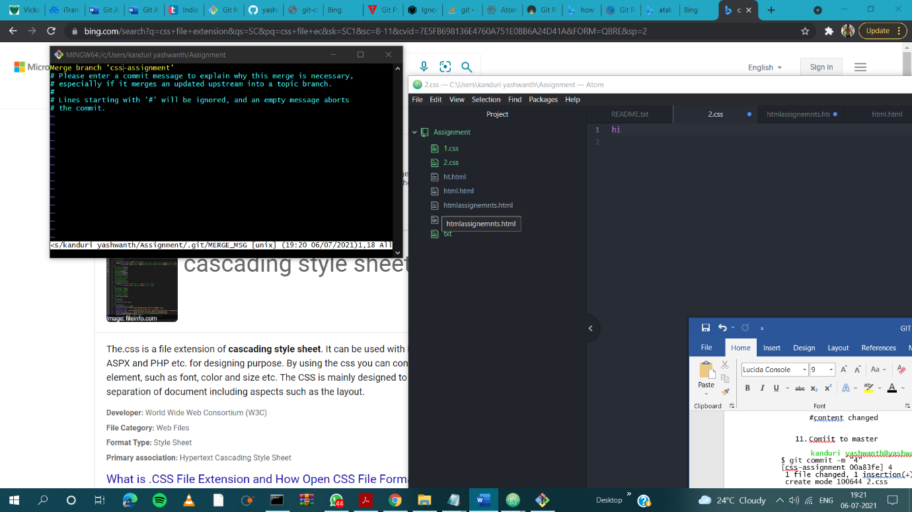

1. Finally delete the css-assignment branch

kanduri yashwanth@yashwanth MINGW64 ~/Assignment (master|MERGING)

$ git branch -D css-assignment

Deleted branch css-assignment (was 00a83fe).

Section 3 (java script )

1. Create a new branch js-assignments

kanduri yashwanth@yashwanth MINGW64 ~/Assignment (master|MERGING)

$ git branch js-assignment

1. Switch to js-assignment branch

kanduri yashwanth@yashwanth MINGW64 ~/Assignment (master|MERGING)

$ git checkout js-assignment

Switched to branch 'js-assignment'

1. Copy all java script assignment inside assignment folder

kanduri yashwanth@yashwanth MINGW64 ~/Assignment (js-assignment)

$ touch 1.js

kanduri yashwanth@yashwanth MINGW64 ~/Assignment (js-assignment)

$ touch 2.js

1. Commit javaScript assignment into js-assignemnt branch

kanduri yashwanth@yashwanth MINGW64 ~/Assignment (js-assignment)

$ git add 1.js

kanduri yashwanth@yashwanth MINGW64 ~/Assignment (js-assignment)

$ git commit -m "1js"

[js-assignment 65e566a] 1js

1. Make minor changes into README.txt file on line 1 belonging to js assignment branch

#content changed

1. Commit those changed files

kanduri yashwanth@yashwanth MINGW64 ~/Assignment (js-assignment)

$ git commit -m "y"

[js-assignment 823e2d3] y

1 file changed, 1 insertion(+), 1 deletion(-)

1. Switch to master branch

kanduri yashwanth@yashwanth MINGW64 ~/Assignment (js-assignment)

$ git checkout master

Switched to branch 'master'

1. Make minor changes into README.txt file on line 1 & commit those changes into master

kanduri yashwanth@yashwanth MINGW64 ~/Assignment (master)

$ git add README.txt

kanduri yashwanth@yashwanth MINGW64 ~/Assignment (master)

$ git commit -m "2"

[master 4b8fe00] 2

1 file changed, 1 insertion(+), 1 deletion(-)

1. Again switch to js-assignments branch

kanduri yashwanth@yashwanth MINGW64 ~/Assignment (master)

$ git checkout js-assignment

Switched to branch 'js-assignment'

1. Make minor changes into few files belonging to js-assignments branch

#content changed

1. Commit those changes

kanduri yashwanth@yashwanth MINGW64 ~/Assignment (js-assignment)

$ git commit -m "3"

[js-assignment 248bb0f] 3

1 file changed, 1 insertion(+)

create mode 100644 2.js

1. Switch to master

kanduri yashwanth@yashwanth MINGW64 ~/Assignment (js-assignment)

$ git checkout master

Switched to branch 'master'

1. Merge js-assignemnts branch into master.confirm all javascript assignments are shown in master

kanduri yashwanth@yashwanth MINGW64 ~/Assignment (master)

$ git merge js-assignment

Auto-merging README.txt

1. Finlly delete the js-assignments branch

Git git git

kanduri yashwanth@yashwanth MINGW64 ~/Assignment (master|MERGING)

$ git branch -D js-assignment

Deleted branch js-assignment (was 248bb0f).

GIT Remoting

Section-3

39.create a github account if your do not have already

Created a github account

Username: yashwanth2108

40.login on into github account

Successfully logged in

41. create new public repository “freshersbatch-june21”

Created repo - <https://github.com/yashwanth2108/freshersbatch-june21.git>

42. Commit and push any sample file to this repository under ‘Assignment’ directory

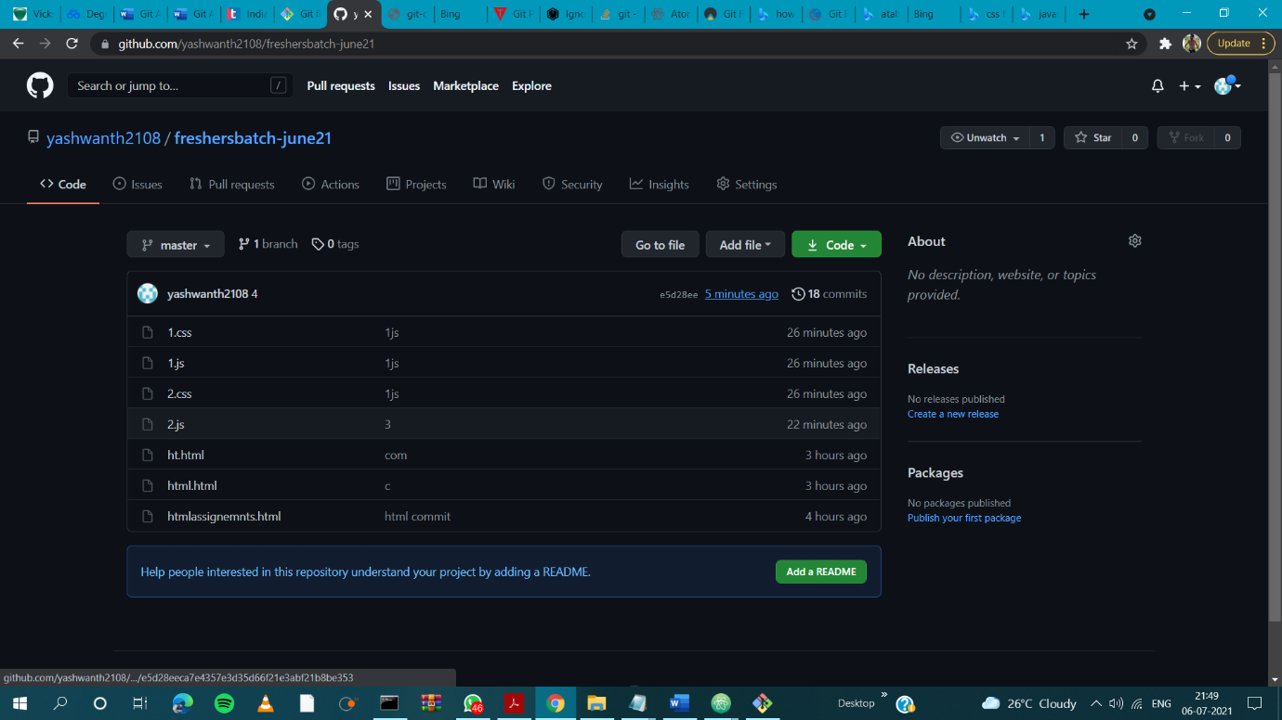

Section 4

1.one developer from project team will create eclipse project ‘sampleProj’ &add sample source code files . then commit all files though thourgh GIT plugin

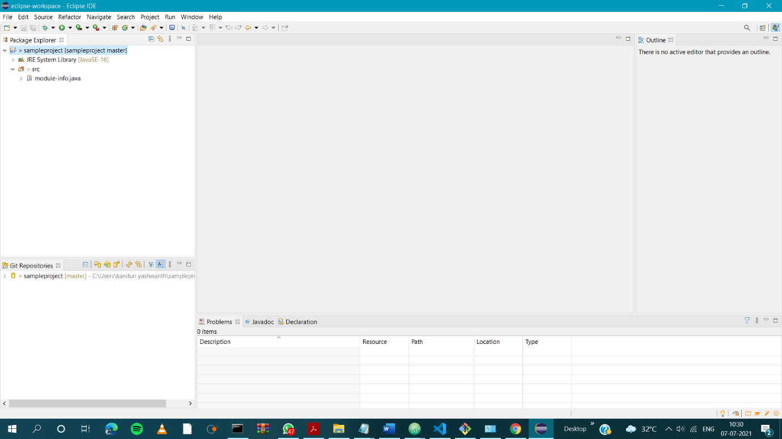

2.collaborate other team members with your github account so they can also modify the committed files

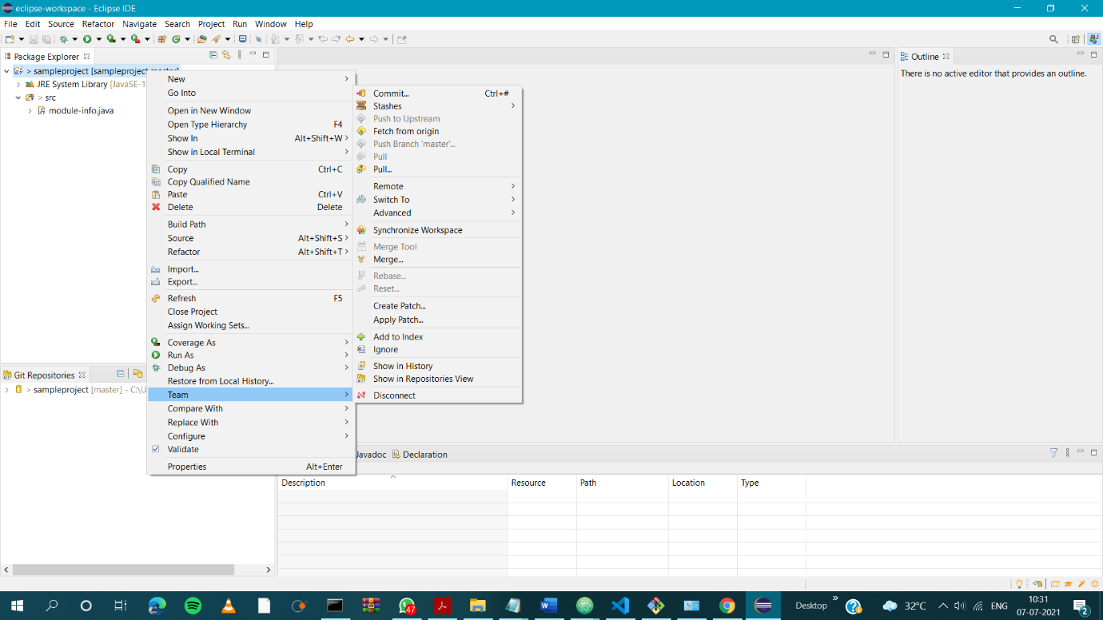

3.other developers from same team will checkout all the files from remote repository this might get conflicts since certain files fail to megre .in such case merge it manually

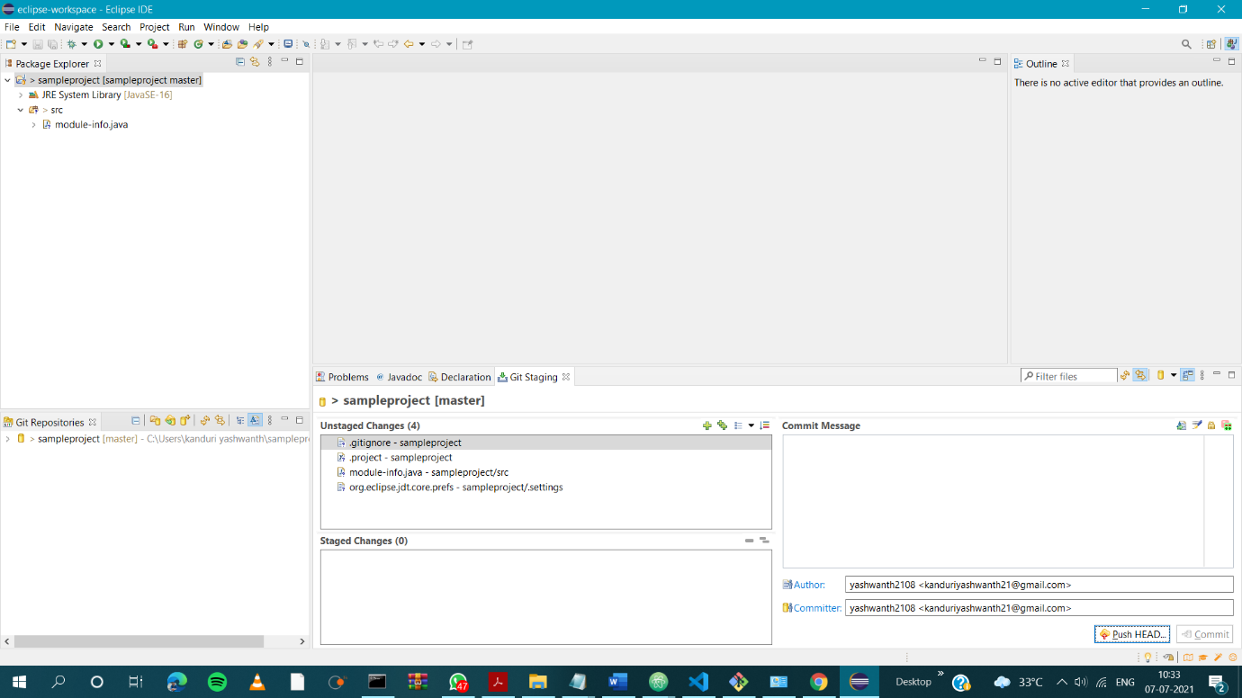

4.commit and push the sample project

